I, Maria Paszkowiak, attest that the results of the 2021 Student Association Executive Office Elections are accurate, and I therefore officially certify this election.

Maria Paszkowiak
Chief Elections Officer/Chief of Operations
The University of Tulsa Student Association

I, the undersigned witness, attest that the results for the 2021 Student Association Executive Office Elections are accurate, and I therefore officially certify this Election.

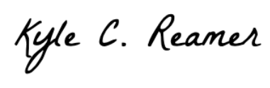

Kyle Reamer
Chief Justice
The University of Tulsa Student Association

Winners Denoted in Bold

President

Kareem Ihmeidan (369)

Vice President

Lanie McKinney (207)
Sean O’Brien (177)

Secretary

Justin Yang (258)
Savannah Sinclair (130)

Treasurer

Kaitlyn Argo (348)

